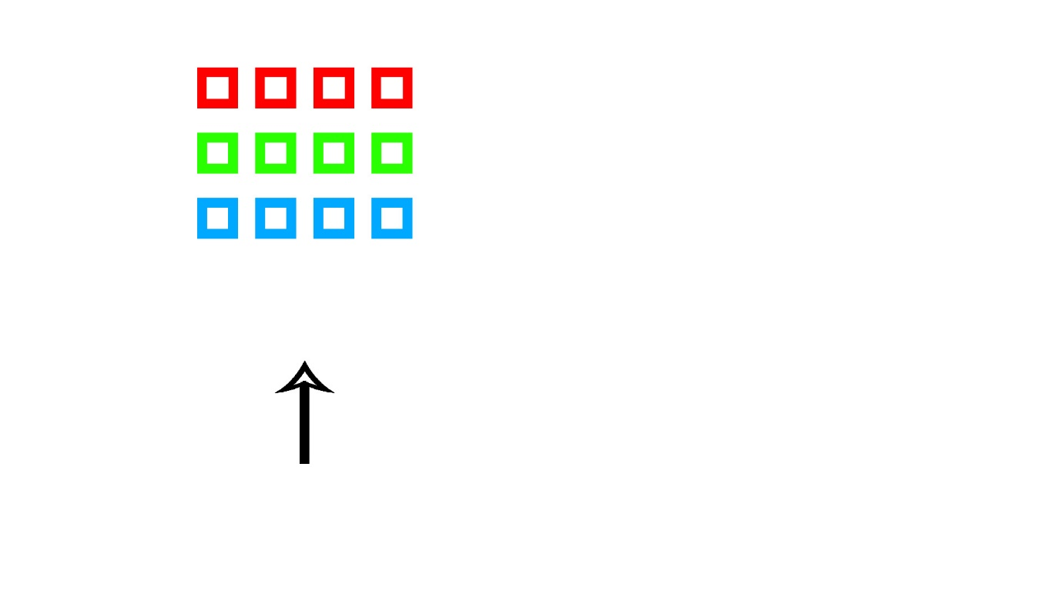The problems we are having is the fact the game has to be 2D creates an issue of the player being able to hit high windows. This is because the low windows are in the way, however after researching different ways to fix this. I have come up with a solution.

If we break the power bar up into 3 parts.

1. 0%-33% of the power being filled
2. 34%-66%
3. 67%-100%

So if give the rows of blocks different tags, we can make the projectile only collide with the tag that power fits into.

For example if I fill up half of the power bar 50%. Then the projectile will only collide with the green blocks (B blocks).

